**🡪 Screenshot of pylint test before make changes.**

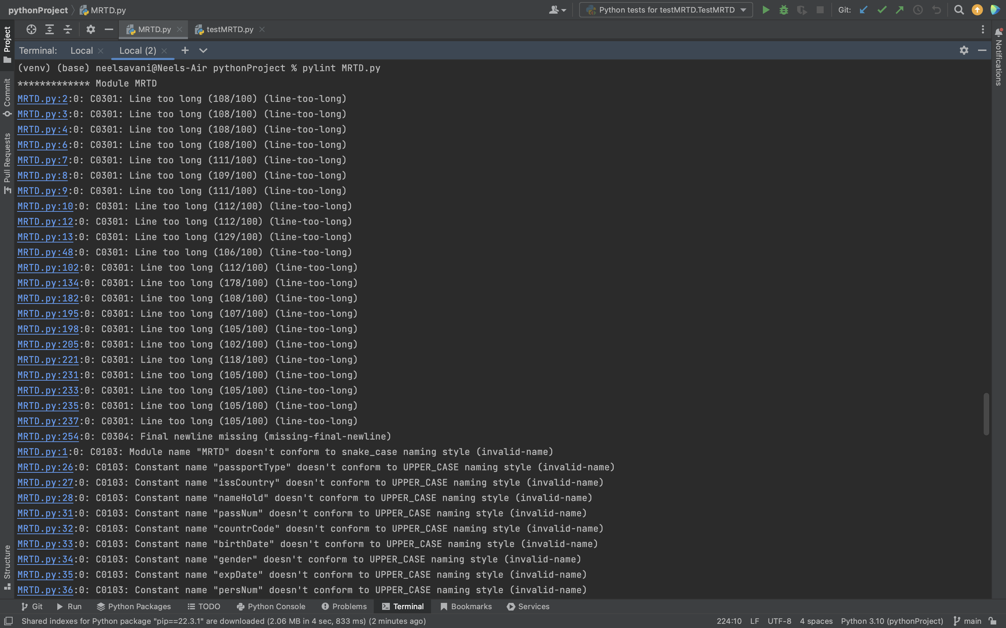

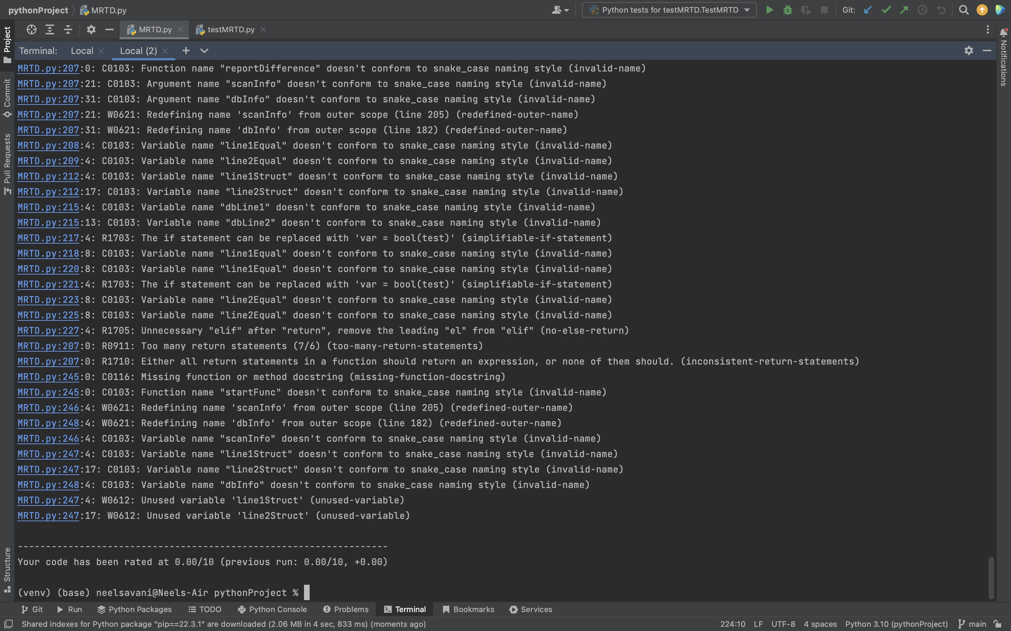

**🡪 Screenshot after make changes in code for pylint**

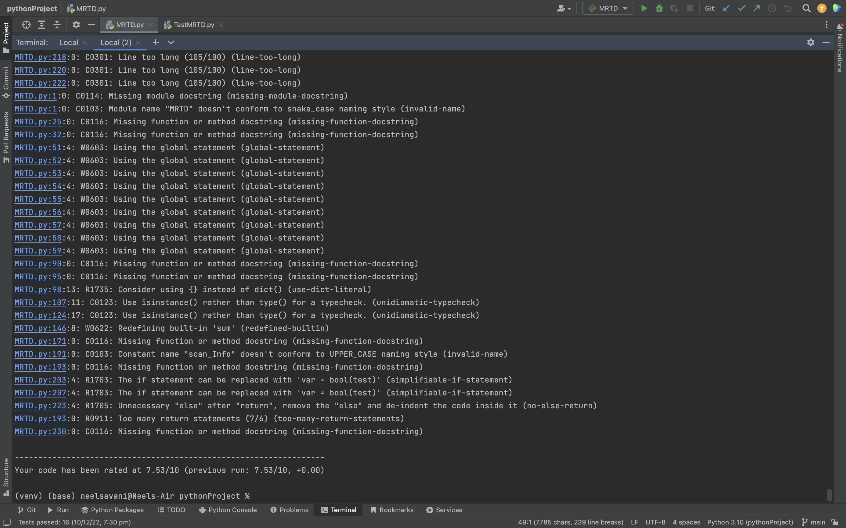

**🡪 Screenshot of code coverage**

